# How to capture request and response XML

One of the best way to inspect transaction data in a request is to capture the XML before it leaves your system. The following guide provides a way to capture this information in an easy to review approach.

## Tools used

1. Windows 7
2. Charles Proxy <http://www.charlesproxy.com/>
   1. Others have used fiddler as an alternative <http://www.fiddler2.com/fiddler2/>
3. c#.NET sample code as provided by IPCommerce.

## Setup

1. Download and install Charles Proxy
2. Install the Charles CA SSL Certificate

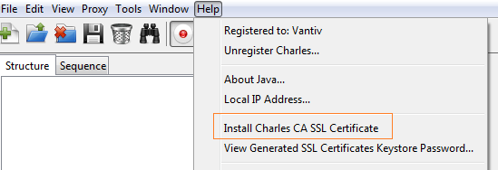

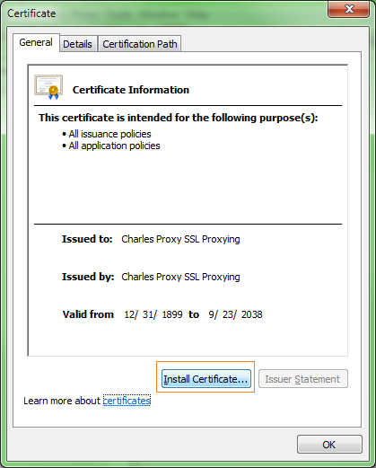

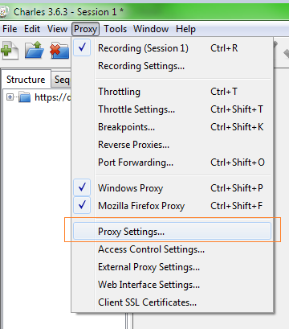

Make sure the following are added to the SSL tab

**Certification test system**

* Developer Portal: apis.cert.vantiv.com
* Payment Web Services: ws-cert.vantiv.com

**Production**

* Developer Portal: apis.vantiv.com

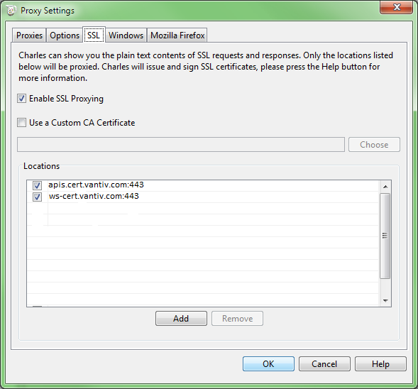

At this point, close Charles and re-open. Open your .NET application and send a transaction. From here you’ll see all of the request and response detail as sent by the application.

